ABL Data Report: Musquash Metabarcoding 2025

Prepared by: Evan Cronmiller

Objectives
- Extract and quantify 77 Musquash eDNA samples
- Develop metabarcoding libraries for one COI (cytochrome c oxidase I) and two 12S (ribosomal RNA), for a total of 3 libraries
- Sequence COI and 12S libraries on the Illumina MiSeq
- Provide raw sequencing data and corresponding sample metadata to end users

1. eDNA Extraction and Quantification
A total of 77 Smith-Root filter samples were received by the Aquatic Biotechnology Lab (ABL) as part of the 2025 Musquash sample set. Prior to extraction, sample filters were cut in half and one half was preserved in 200 µL absolute ethanol and stored at -80°C, while the remaining half was processed. DNA was extracted from filters with the DNeasy Blood and Tissue Kit (Qiagen) and an in-house modified protocol using the QIACube Connect instrument (Qiagen). Samples were extracted in four batches; 22 eDNA samples plus two extraction negative control samples (ENEG) for three batches and 11 eDNA samples plus one ENEG for the fourth batch, yielding a total of 84 samples.
Following extraction, all samples were assayed using a Qubit Fluorometer (Invitrogen) with the dsDNA High Sensitivity Assay Kit (Invitrogen) to measure DNA concentration. Assays were performed according to the kit manufacturer’s protocol and using 2 µL DNA per sample. DNA concentrations for the eDNA samples ranged from 0.315 to 5.44 ng/µL and concentrations of replicate samples per sampling site were generally consistent (Figure 1). The two field negative control samples (Sample No. 925040 and 925077; ABL Sample ID 45148 and 45185) and all ENEG sample had DNA concentrations below the limit of quantification (not pictured).

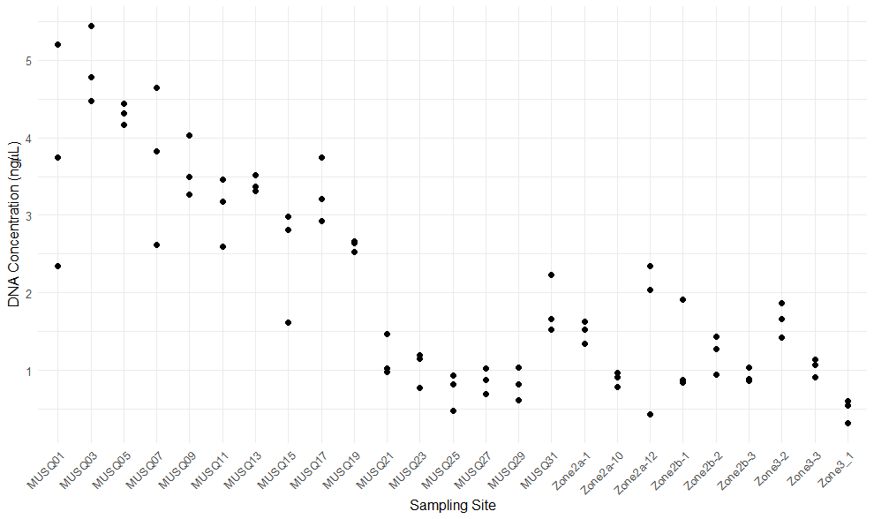
Figure 1: DNA concentration of eDNA extracts grouped by sampling site. Each point represents a replicate eDNA sample per 2025 Musquash site sampled.

2. Develop metabarcoding libraries for COI and 12S loci
Library 12S-A comprised of 90 Musquash eDNA samples previously extracted by CEGA in 2023 and provided to the ABL. Libraries 12S-B and COI were comprised of 77 Musquash samples and 7 ENEGs extracted by the ABL in 2025 as described in Objective 1 (see metadata files provided separately for sample details). To reduce PCR and sequencing biases, eDNA samples per library were subsampled in a randomized order prior to PCR amplification. For all PCRs we used custom fusion primers (IDT) with Illumina adaptor and unique index barcode sequences added on both forward and reverse strands, enabling single-step PCR amplification and direct sequencing of PCR products. PCRs were performed in triplicate for all samples and included a PCR negative control sample (water) for each uniquely indexed pair of primers.
Mifish-U-R
The PCRs for both 12S libraries used 12S_248F_RADS_For/Mifish-U-R primers and PCR cycling program per He et al., 2023 (Table 1). For 12S-A PCRs, each 25 µL reaction contained 0.5 µL each of forward and reverse fusion primers, 7.5 µL ultrapure water, 12.5 µL Multiplex Master Mix (Qiagen), and 4 µL DNA, which is 1 µL more DNA than typical, to increase the concentration of amplicons which were shown to have low concentration in previous PCR assays. For 12S-B PCRs, each 25 µL reaction contained 0.5 µL each of forward and reverse fusion primers, 8.5 µL ultrapure water, 12.5 µL Multiplex Master Mix (Qiagen), and 3 µL DNA.
The PCRs for the COI library used either mlCOIintF/jgHCO2198 primers and PCR cycling program from Lacoursière-Roussel et al. (2018) for all 84 samples, or, for a subset of 12 replicate eDNA samples, new BF/BR primers and PCR cycling program per Geneviève Parent (Table 1). The twelve (12) eDNA samples selected for amplification with the BF/BR COI primers were denoted in sequence data files with the suffix “-B”. All COI PCRs used the sample reaction volumes: 0.5 µL each of forward and reverse fusion primers, 8.5 µL ultrapure water, 12.5 µL Multiplex Master Mix (Qiagen), and 3 µL DNA, for a total volume of 25 µL.
Replicate PCR products for each sample were pooled, excluding PCR negative controls, and all were screened for amplification success or indication of contamination using a TapeStation 4200 system with D1000 ScreenTapes and reagents (Agilent). All PCR products from eDNA samples showed positive amplification at both COI and 12S loci, although to varying efficiencies. Most samples within the 12S-A library set indicated a (weaker) secondary amplicon present at a size of ~450 bp, in addition to the typical 12S amplicon at ~350 bp. The source of this amplicon in unknown, but appears to be a result of the increase DNA input of 12S-A PCRs compared to 12S-B PCRs (this amplicon can be seen very faintly in some 12S-B PCR products). All COI PCRs were successful for both the standard mlCOIintF/jgHCO2198 primers and BF/BR primers, although the amplicon size differed at ~520 and ~420 bp, respectively. All extraction negative control samples from both 2023 and 2025 sample cohorts showed no PCR amplification at either loci, indicating successful contamination control during extraction. Of the three field negative control samples (one from 2023 cohort and two from 2025 cohort), only one field negative control (Sample No. 925040; ABL Sample ID 45148) showed very weak amplification at both loci, suggesting minimal DNA is present in this sample.
Good quality PCR products were then purified using AxyPrep MAG PCR Clean-up beads (Axygen), following the manufacturer’s protocol. Purified PCR products were quantified using the AccuClear Ultra High Sensitivity dsDNA Quantitation kit (Biotium), then all samples in a library were pooled in roughly equimolar amounts using a epMotion 5073 liquid handling instrument. For the COI library, 50 ng DNA per sample was pooled (up to maximum 20 µL volume; 10 µL maximum for field and extraction negative controls). For 12S libraries, 15 ng DNA per sample was pooled (maximum 25 µL; 10 µL for negative controls). Pooled libraries were purified and size-selected using AxyPrep MAG PCR Clean-up beads to remove DNA fragments < 200 bp in length and chemical impurities.
The quality of completed libraries was evaluated using D1000 High Sensitivity ScreenTapes and reagents for the TapeStation 4200 system (Agilent) to visualize successful removal of impurities and short DNA fragments. All three libraries showed successful removal of short DNA fragments, however, the completed 12S-A library contained a small amount of the larger secondary amplicon discussed above, and the COI library showed a bimodal distribution of DNA fragment size corresponding to the different amplicon sizes from the two primer sets.
Libraries were assayed using the NEBNext Library Quant Kit for Illumina (New England Biolabs) on a QuantStudio 7 qPCR instrument (Applied Biosystems), following the manufacturer’s protocol, and assay values were used to calculate library concentration using the NEBioCalculator web tool (https://nebiocalculator.neb.com/#!/qPCRlibQnt).
Table 1: PCR specifications for COI and 12S metabarcoding
Metabarcoding  Gene Target | Forward Primer  (Reference) | Forward Primer Sequence (5’ – 3’) | Reverse Primer  (Reference) | Reverse Primer Sequence (5’ – 3’) | PCR cycling program
Cytochrome c oxidase, subunit I (COI)  (Lacoursière-Roussel et al., 2018) | mlCOIintF  (Leray et al., 2013) | GGWACWGGWTGAACWGTWTAYCCYCC | jgHCO2198  (Geller et al., 2013) | TAIACYTCIGGRTGICCRAARAAYCA | Step 1) 95°C for 15 min  Step 2*) 95°C for 30 s  54°C for 90 s  72°C for 60 s  *35 cycles of step 2  Step 3) 72°C for 10 min
Cytochrome c oxidase, subunit I (COI)  (from Geneviève Parent) | BF | ACWGGWTGRACWGTNTAYCC | BR | ARYATDGTRATDGCHCCDGC | Step 1) 95°C for 15 min  Step 2*) 95°C for 30 s  54°C for 90 s  72°C for 60 s  *40 cycles of step 2  Step 3) 72°C for 10 min
12S ribosomal RNA (12S)  (He et al., 2023) | 12S_248F_RADS_For  (He et al., 2022) | CGTGCCAGCCACCGCGGTT | Mifish-U-R  (Miya et al., 2015) | CATAGTGGGGTATCTAATCCCAGTTTG | Step 1) 95°C for 15 min  Step 2*) 95°C for 30 s  58°C for 90 s  72°C for 60 s  *37 cycles of step 2  Step 3) 72°C for 10 min

3. COI and 12S library sequencing on the MiSeq
Completed metabarcoding libraries were sequenced on the MiSeq platform (Illumina) using the v3 (600-cycle, paired-end) kit for COI and v2 (500-cycle, paired-end) kit for 12S libraries (Table 2).
For COI sequencing, the library were prepared to a final concentration of 14 pM, with a 15% spike-in of 14 pM PhiX control DNA, which were concentrations determined from previous successful sequencing projects. Sequence data metrics were overall fair, while the read quality was good. The cluster density of 953 ± 21 K/mm² is at the lower than typical range of ~1000-1200 K/mm² and the number clusters passing filter of 75.88 ± 8.84% indicates cluster generation was suboptimal, which led to a lower data yield of 10.89 Gb. However, the proportion of high quality sequencing reads (>Q30) was 82.66%, which indicates good overall sequence data quality (Table 2).
For 12S sequencing, both libraries were prepared to a final concentration of 8 pM with a 20% spike-in of 8 pM PhiX control DNA. The sequence data metrics for both 12S-A and 12S-B were overall good. The cluster densities for 12S-A and 12S-B were 715 ± 40 and 709 ± 31K/mm², respectively, which is at the low end of the target range of ~700-900 K/mm² for v2 MiSeq kits. However, the proportion of clusters passing filter were 92.19 ± 1.92 and 92.87 ± 1.67%, suggesting good cluster generation of DNA for both sequencing runs. The total sequence data yield for 12S-A and 12S-B were 7.44 and 7.52 Gb, respectively, which is typical for this sequence chemistry. The proportion of >Q30 reads was 80.95% for 12S-A and 79.24% for 12S-B, which indicates good sequence data quality for both libraries (Table 2).
Table 2. Summary of sequencing run parameters and sequence data metrics
Library | MiSeq Reagent Kit  (Chemistry) | Library/PhiX Concentration  (pM) | PhiX Spike-in  (%) | Cluster Density (K/mm²) | Clusters Passing Filter  (%) | Reads >Q30  (%) | Data Yield (Gb)
COI | v3  (600-cycle, paired-end) | 14 | 15 | 953 ± 21 | 75.88 ± 8.84 | 82.66 | 10.89
12S-A | v2  (500-cycle, paired-end) | 8 | 20 | 715 ± 40 | 92.19 ± 1.92 | 80.95 | 7.44
12S-B | v2  (500-cycle, paired-end) | 8 | 20 | 709 ± 31 | 92.87 ± 1.67 | 79.24 | 7.52

4. Provide Raw Sequencing Data
The sequence data for the COI library and two 12S libraries (12S-A and 12S-B) were retrieved from the MiSeq and backed up on an ABL external hard drive. The sequence data and metadata were uploaded to the shared “Musquash” project page in MS Teams in the “2025 Musquash Data” folder.

Summary
- Extract and quantify 77 Musquash eDNA samples
- A total of 77 frozen Smith-Root filter samples were provided to the ABL for extraction
- All samples were extracted from half-filters using Qiagen’s DNeasy Blood and Tissue kit and QIAcube Connect instrument, and included 7 total ENEGs across 4 extractions, for a total of 84 samples
  - Remaining eDNA extracts and half-filters were archived in ABL -80°C freezers.
- DNA extracts were quantified using the Qubit 1x dsDNA HS Assay and Qubit instrument. DNA concentrations for eDNA samples were generally low, but consistent by sampling site. Both field negative control samples and ENEGs did not contain quantifiable levels of DNA.

Develop metabarcoding libraries for COI and 12S loci
- Two 12S libraries were developed using 12S_248F_RADS_For/Mifish-U-R primers. The 12S-A library consisted of 90 DNA samples, extracted previously by CEGA in 2023, while the 12S-B library consisted of 84 samples processed by the ABL in 2025. 12S PCR successfully amplified all eDNA samples, although 12S-A PCRs showed presence of a secondary amplicon of unknown origin. Completed 12S libraries looked acceptable upon final Tapestation evaluation, although the 12S-A library still indicated some amount of secondary amplicon.
- One COI library was developed using two separate PCR primer sets; one set (mlCOIintF/jgHCO2198) was used for all 84 2025 Musquash samples, while the other set (BF/BR) was used for 12 repeated samples to enable intra-library comparisons of the sequence data for the primer sets. COI PCR was successful for all samples. The completed library was good quality and yielded two different DNA fragment sizes, corresponding to the two PCR primer sets.

3 & 4. Sequence COI and 12S libraries on the Illumina MiSeq and provide sequence data
- All three metabarcoding libraries were sequenced on the MiSeq, with v3 600-cycle sequencing chemistry for COI and v2 500-cycle chemistry for 12S-A and 12S-B.
- COI sequencing yielded lower than typical cluster density and clusters passing filter, which led to a lower sequence data output, while clustering metrics and data output for 12S libraries were typical.
- Sequence data metrics (>Q30) indicate high quality data was obtained for all libraries.
- The raw sequencing data and metadata for all libraries were uploaded to the MS Teams project page “Musquash” in the “2025 Musquash Data” folder.

References

Geller, J., Meyer, C., Parker, M., and Hawk, H. (2013). Redesign of PCR primers for mitochondrial cytochrome c oxidase subunit I for marine invertebrates and application in all-taxa biotic surveys. Molecular Ecology Resources 13, 851-861.

He, X., Jeffery, N.W., Stanley, R.R.E., Hamilton, L.C., Rubidge, E.M., and Abbott, C.L. (2023). eDNA metabarcoding enriches traditional trawl survey data for monitoring biodiversity in the marine environment. ICES Journal of Marine Science 80, 1529-1538.

He, X., Stanley, R.R.E., Rubidge, E.M., Jeffery, N.W., Hamilton, L.C., Westfall, K.M., Gilmore, S.R., Roux, L-M.D., Gale, K.S.P., Heaslip, S.G., et al. (2022). Fish community surveys in eelgrass beds using both eDNA metabarcoding and seining: implications for biodiversity monitoring in the coastal zone. Canadian Journal of Fisheries and Aquatic Sciences 79, 1335–1346.

Lacoursière-Roussel, A., Howland, K., Normandeau, E., Grey, E.K., Archambault, P., Deiner, K., Lodge, D.M., Hernandez, C., Leduc, N., and Bernatchez, L. (2018). eDNA metabarcoding as a new surveillance approach for coastal Arctic biodiversity. Ecology and Evolution 8, 7763-7777.

Miya, M., Sato, Y., Fukunaga, T., Sado, T., Poulsen, J.Y., Sato, K., Minamoto, T., Yamamoto, S., Yamanaka, H., Araki, H., et al. (2015). MiFish, a set of universal PCR primers for metabarcoding environmental DNA from fishes: detection of more than 230 subtropical marine species. Royal Society Open Science 2, 150088.

